# Logistic Regression

|  |  |
| --- | --- |
| **Model** | **Tuned Parameters** |
| Log Model 1 | LogisticRegression(penalty='l2',max_iter=5,C = 50,solver = 'newton-cg') |
| Log Model 2 | LogisticRegression(penalty='l2',max_iter=1,C = 20,solver = 'sag') |
| Log Model 3 | LogisticRegression(penalty='none',max_iter=2,C = 50,solver = 'sag') |
| Log Model 4 | LogisticRegression(penalty='l1',max_iter=2,C = 5,solver = 'saga') |
| Log Model 5 | LogisticRegression(penalty='elasticnet',max_iter=2,C = 5,solver = 'saga',l1_ratio = 0.9) |

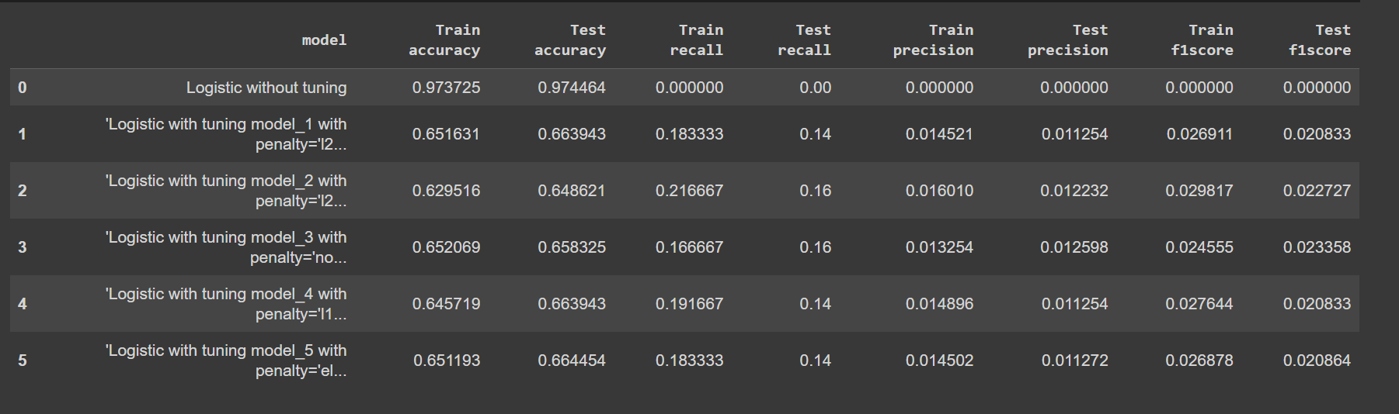

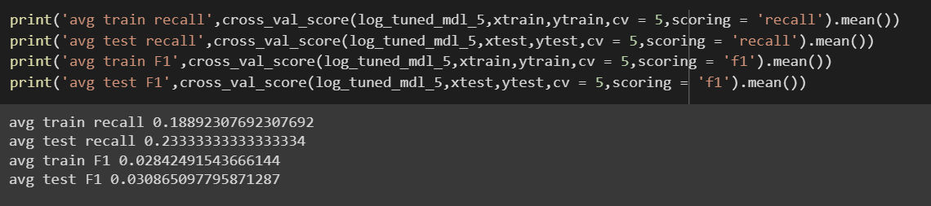

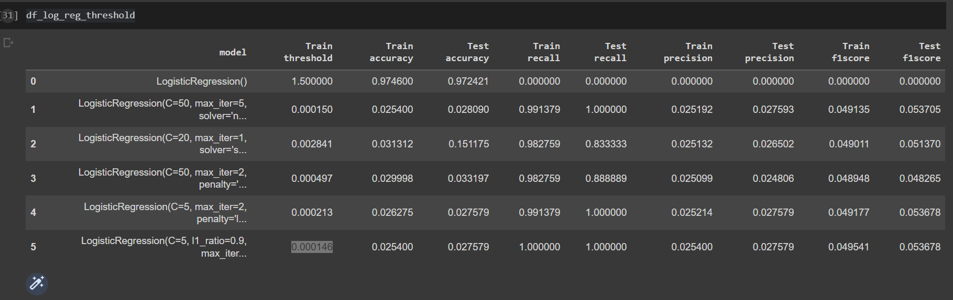

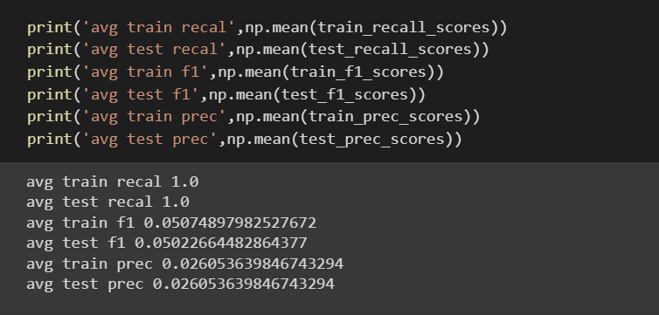

# KNN

|  |  |
| --- | --- |
| **Model** | **Tuned Parameters** |
| KNN Model 1 | KNeighborsClassifier(n_neighbors= 1, leaf_size = 3, algorithm = 'ball_tree', p =2 ,weights = 'uniform') |
| KNN Model 2 | KNeighborsClassifier(n_neighbors= 1, leaf_size = 1, algorithm = 'ball_tree', p =2 ,weights = 'uniform') |

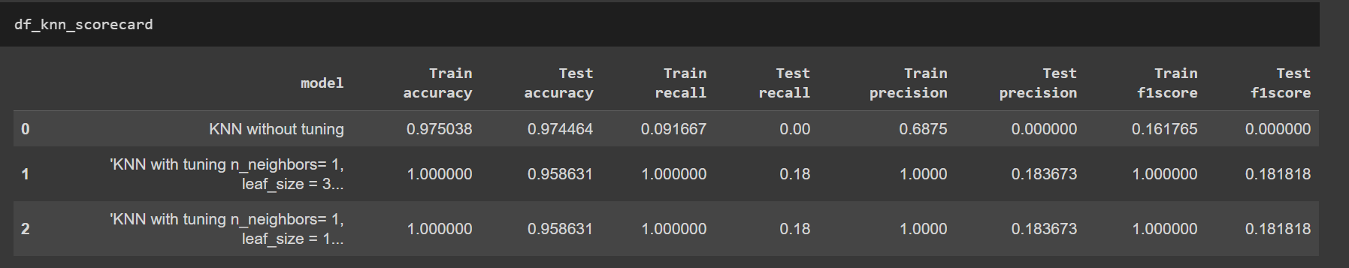

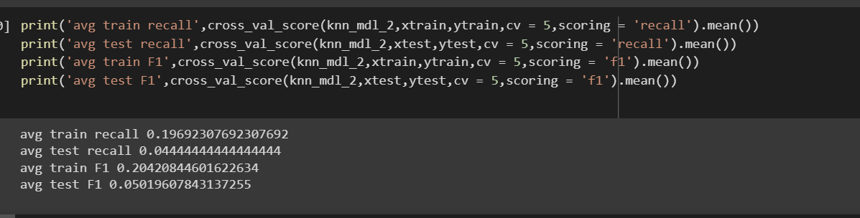

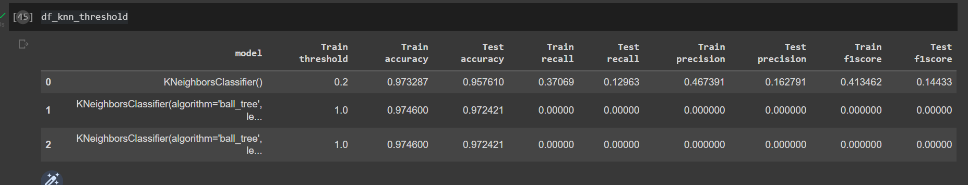

Threshold is checked for KNN without tuning model

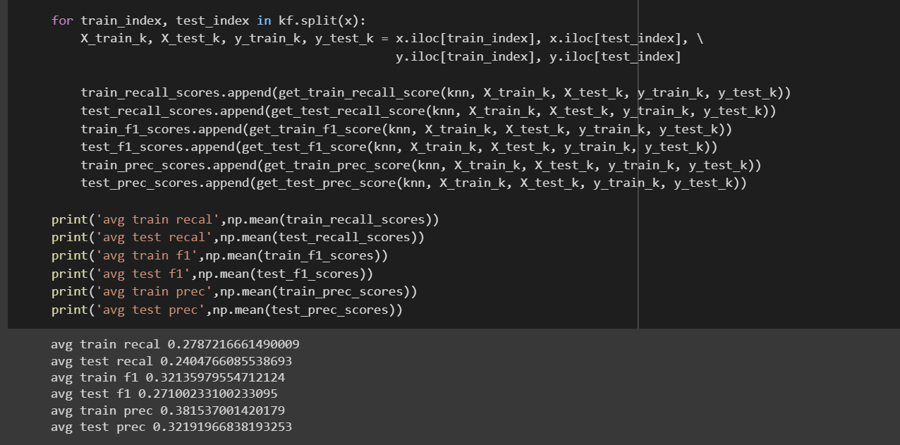

# Naïve Bayes

|  |  |
| --- | --- |
| **Model** | **Tuned Parameters** |
| Naïve Bayes Model 1 | GaussianNB(priors=[0.9,0.1],var_smoothing= 1e-05) |
| Naïve Bayes Model 2 | GaussianNB(priors=[0.8,0.2],var_smoothing= 1e-07) |
| Naïve Bayes Model 3 | GaussianNB(priors=[0.4,0.6],var_smoothing= 1) |

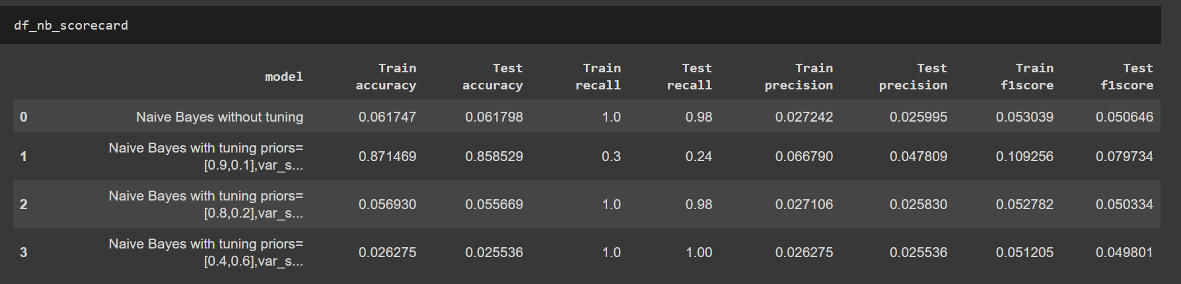

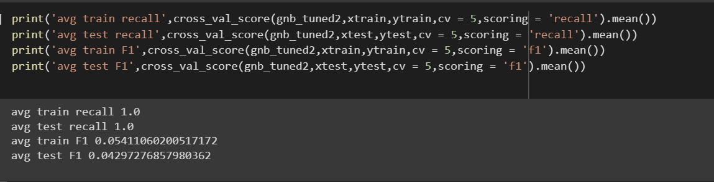

Did not check for Threshold here as recall is very high already

# Decision Tree

|  |  |
| --- | --- |
| **Model** | **Tuned Parameters** |
| DT Model 1 | DecisionTreeClassifier(max_depth = 10, max_features= 30, max_leaf_nodes=20,min_samples_leaf= 5,min_samples_split=10) |
| DT Model 2 | DecisionTreeClassifier(max_depth = 10, max_features= 40, max_leaf_nodes=25,min_samples_leaf= 5,min_samples_split = 11) |
| DT Model 3 | DecisionTreeClassifier(max_depth = 10, max_features= 40, max_leaf_nodes=24,min_samples_leaf= 5,min_samples_split = 11) |
| DT Model 4 | DecisionTreeClassifier(max_depth = 10, max_features= 40, max_leaf_nodes=24,min_samples_leaf= 5,min_samples_split = 11,class_weight={0: 1, 1: 100}) |
| DT Model 5 | DecisionTreeClassifier(max_depth = 10, max_features= 40, max_leaf_nodes=24,min_samples_leaf= 5,min_samples_split = 11,class_weight="balanced") |
| DT Model 6 | DecisionTreeClassifier(max_depth = 10, max_features= 40, max_leaf_nodes=24,min_samples_leaf= 5,min_samples_split = 11,class_weight="balanced",ccp_alpha = 0.08) |
| DT Model 7 | DecisionTreeClassifier(max_depth = 10, max_features= 40, max_leaf_nodes=24,min_samples_leaf= 5,min_samples_split = 11,class_weight="balanced",ccp_alpha = 0.0001) |

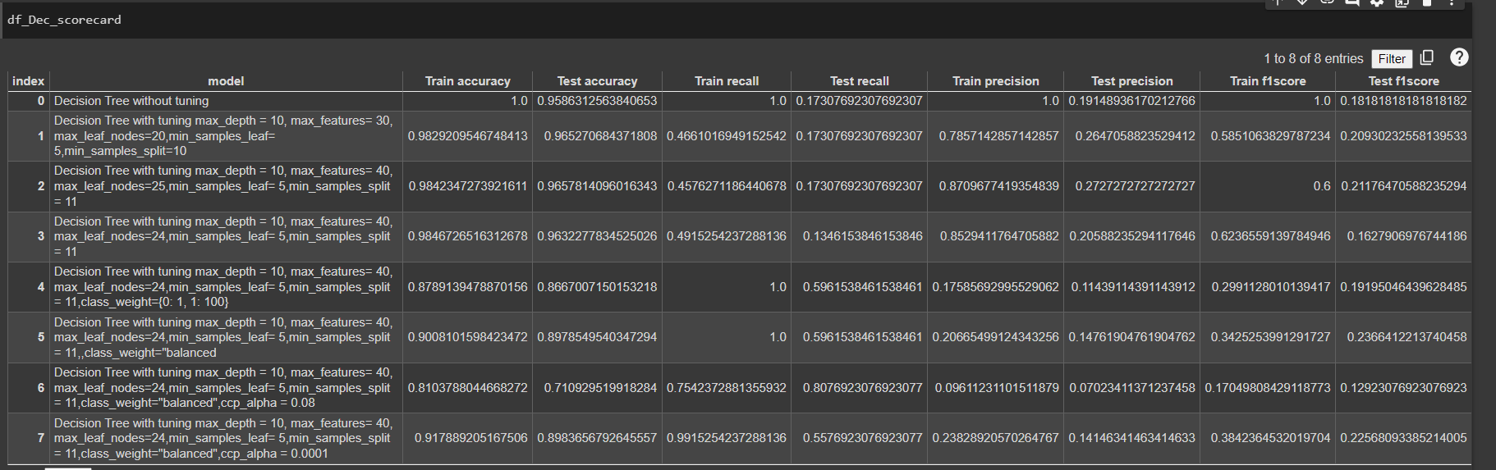

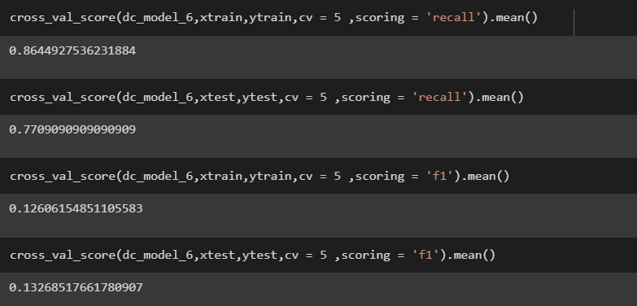

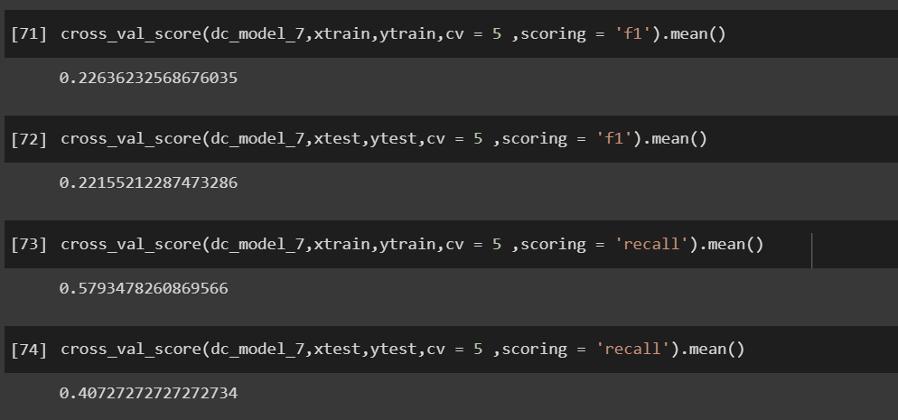

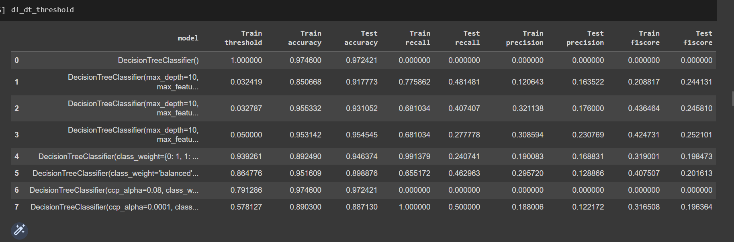

After threshold change model 7 worked better.

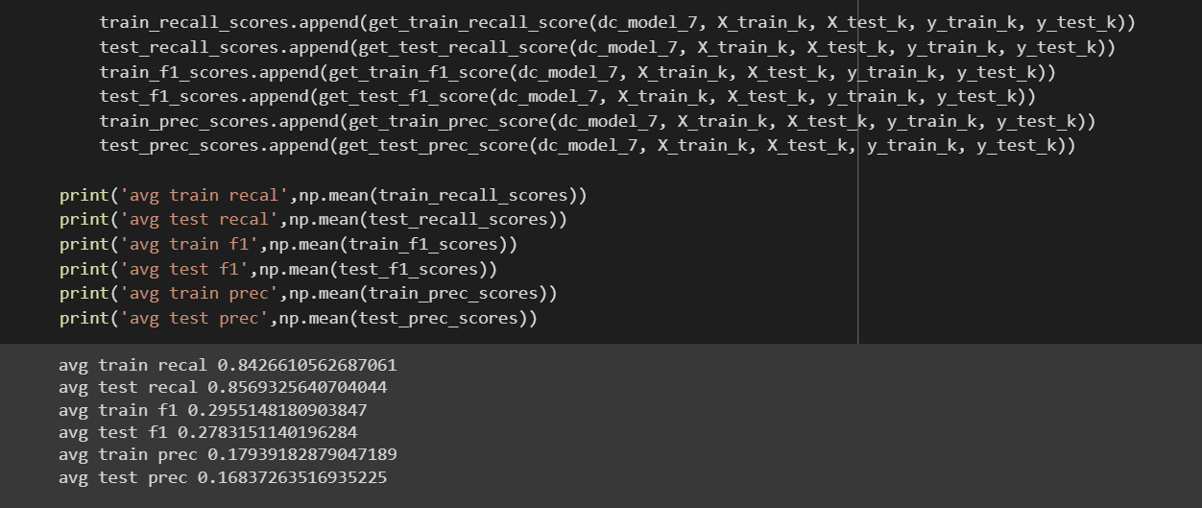

# Random Forest

|  |  |
| --- | --- |
| **Model** | **Tuned Parameters** |
| RF Model 1 | RandomForestClassifier(max_depth = 10, max_features= 40, max_leaf_nodes=24,min_samples_leaf= 5,min_samples_split = 11,class_weight="balanced",ccp_alpha = 0.08) |
| RF Model 2 | RandomForestClassifier(max_depth = 10, max_features= 40, max_leaf_nodes=24,min_samples_leaf= 5,min_samples_split = 11,class_weight="balanced",ccp_alpha = 0.0001) |
| RF Model 3 | RandomForestClassifier(n_estimators = 37,max_depth = 10, max_features= 40, max_leaf_nodes=24,min_samples_leaf= 5,min_samples_split = 11,class_weight="balanced",ccp_alpha = 0.08) |
| RF Model 4 | RandomForestClassifier(n_estimators = 30,max_depth = 10, max_features= 40, max_leaf_nodes=24,min_samples_leaf= 5,min_samples_split = 11,class_weight="balanced",ccp_alpha = 0.0001) |
| RF Model 5 | RandomForestClassifier(n_estimators = 30,criterion = 'entropy',max_depth = 10, max_features= 40, max_leaf_nodes=24,min_samples_leaf= 5,min_samples_split = 11,class_weight="balanced",ccp_alpha = 0.0001) |
| RF Model 6 | RandomForestClassifier(n_estimators = 30,min_weight_fraction_leaf = 0.1,max_depth = 10, max_features= 40, max_leaf_nodes=24,min_samples_leaf= 5,min_samples_split = 11,class_weight="balanced",ccp_alpha = 0.0001) |

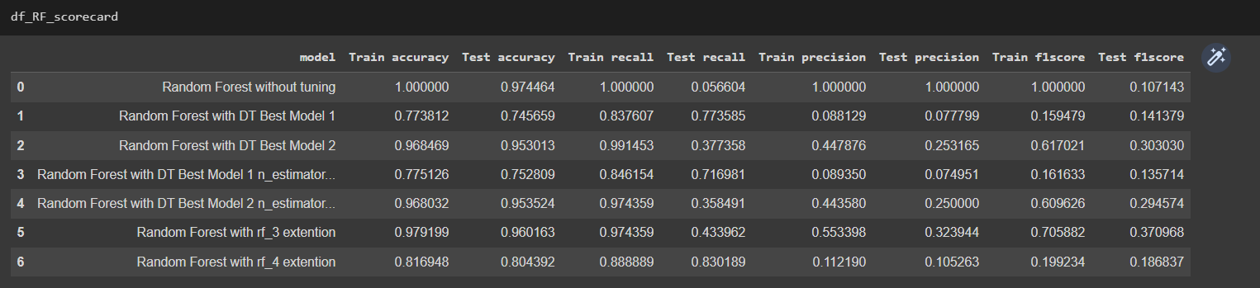

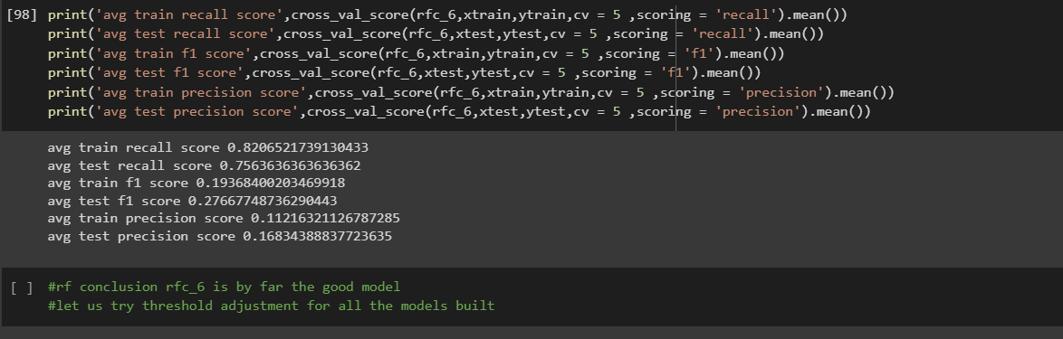

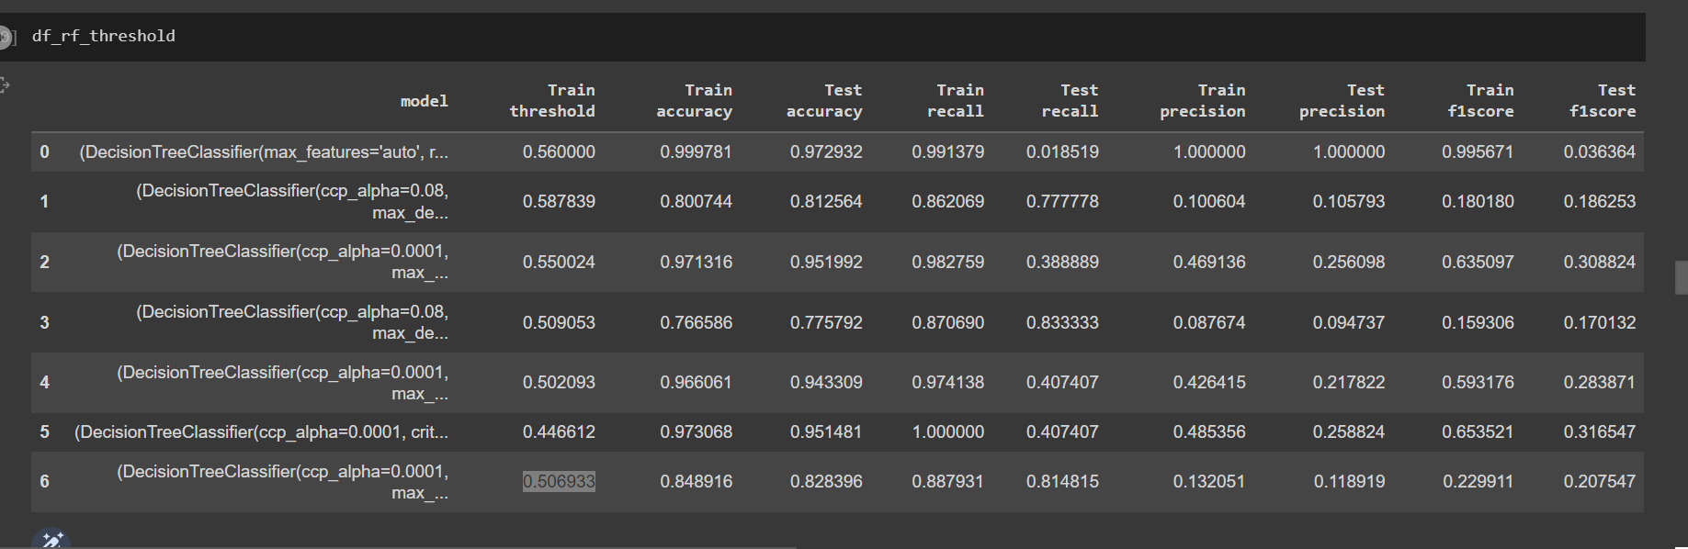

For rf_threshold model 6

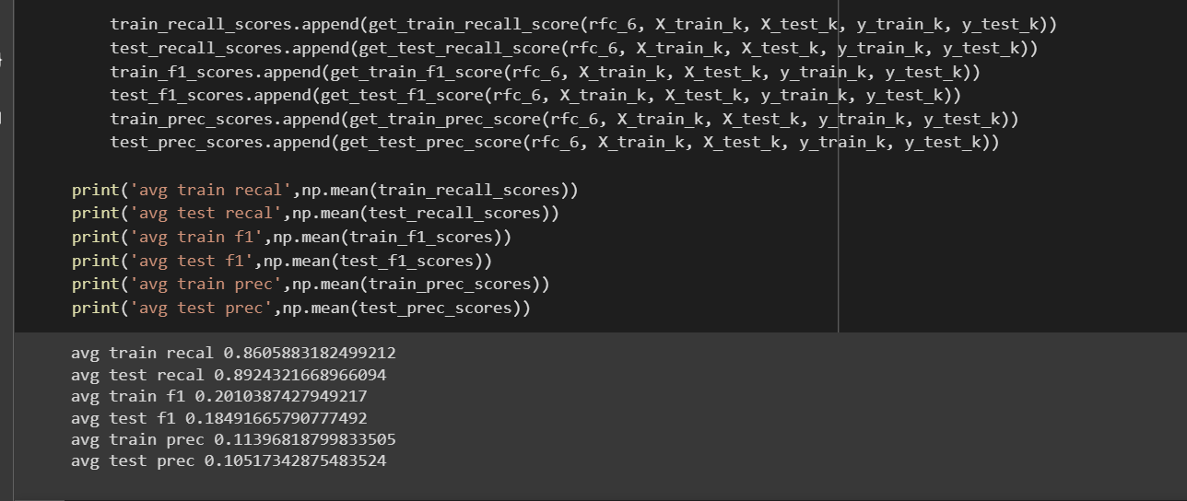

For threshold model 5

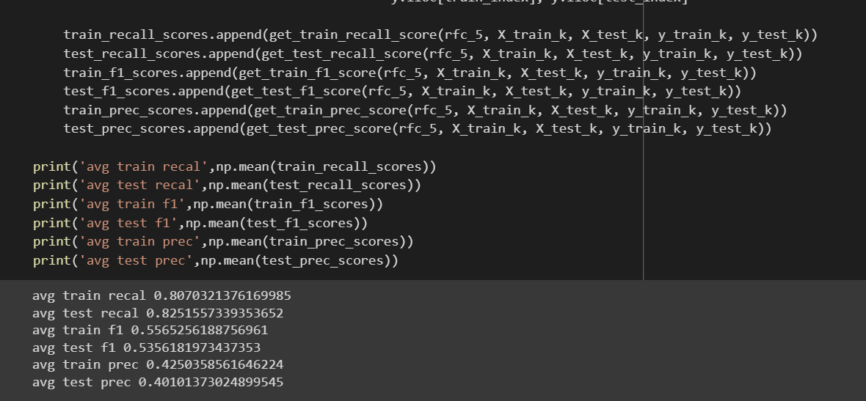

RF_5 threshold adjustment gives good results

# Gradient Boosting

|  |  |
| --- | --- |
| **Model** | **Tuned Parameters** |
| GB Model 1 | GradientBoostingClassifier(init= rfc_6) |
| GB Model 2 | GradientBoostingClassifier(learning_rate= 0.01,loss = 'deviance',init= rfc_5) |
| GB Model 3 | GradientBoostingClassifier(n_estimators = 2,learning_rate= 0.01,loss = 'deviance',init= rfc_5) |
| GB Model 4 | GradientBoostingClassifier(n_estimators = 2,learning_rate= 0.01,min_samples_split = 4,loss = 'deviance',init= rfc_5) |
| GB Model 5 | GradientBoostingClassifier(n_estimators = 2,learning_rate= 0.01,min_samples_split = 4,min_samples_leaf = 9,min_weight_fraction_leaf = 0.1,loss = 'deviance',init= rfc_5) |
| GB Model 6 | GradientBoostingClassifier(n_estimators = 2,max_depth = 16,learning_rate= 0.01,min_samples_split = 4,min_samples_leaf = 9,min_weight_fraction_leaf = 0.1,loss = 'deviance',init= rfc_5) |
| GB Model 7 | GradientBoostingClassifier(n_estimators = 2,max_depth = 16,max_features = 9,learning_rate= 0.01,min_samples_split = 4,min_samples_leaf = 9,min_weight_fraction_leaf = 0.1,loss = 'deviance',init= rfc_5) |
| GB Model 8 | GradientBoostingClassifier(n_estimators = 2,max_depth = 16,max_features = 9,max_leaf_nodes = 18,learning_rate= 0.01,min_samples_split = 4,min_samples_leaf = 9,min_weight_fraction_leaf = 0.1,loss = 'deviance',init= rfc_5) |
| GB Model 9 | GradientBoostingClassifier(n_estimators = 2,ccp_alpha = 0.0001,tol = 0.2,max_depth = 16,max_features = 9,max_leaf_nodes = 18,learning_rate= 0.01,min_samples_split = 4,min_samples_leaf = 9,min_weight_fraction_leaf = 0.1,loss = 'deviance',init= rfc_5) |

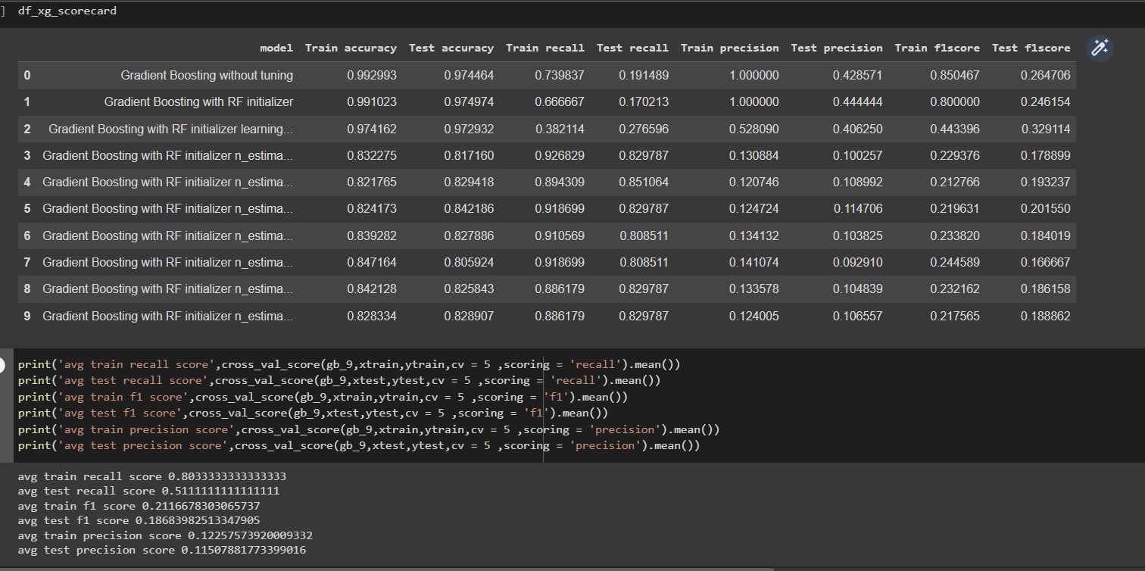

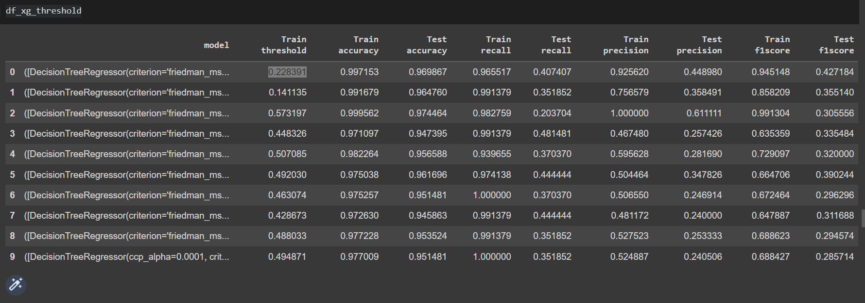

Gb with rfc_5 initializer with default parameters gave good scores after threshold adjustment

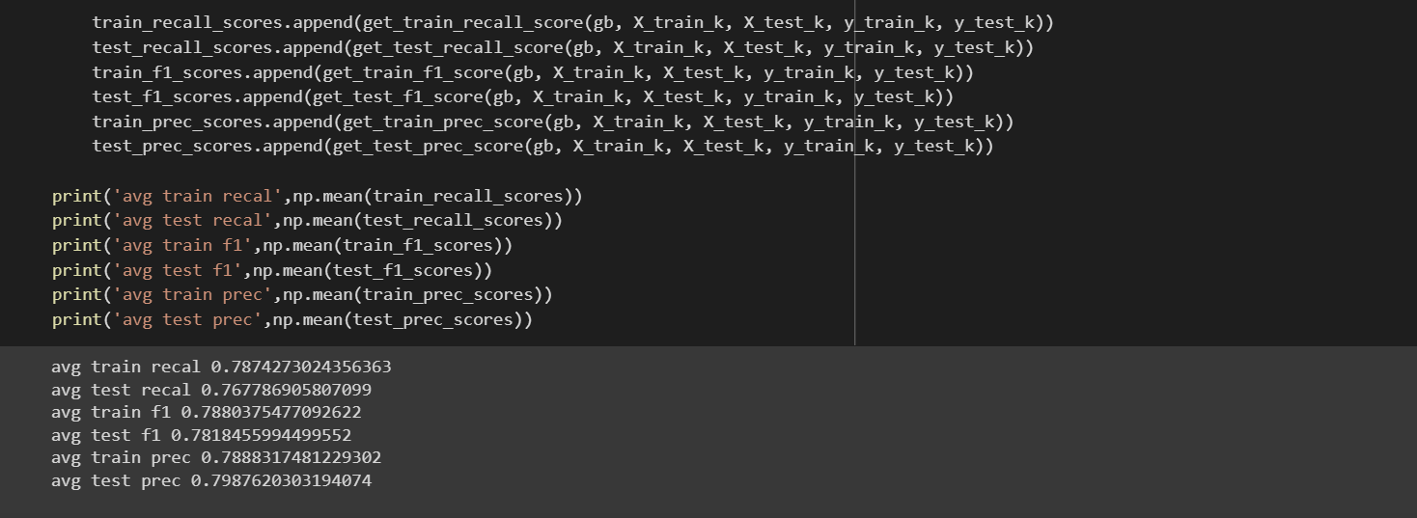

# Ada Boost

Parameters:

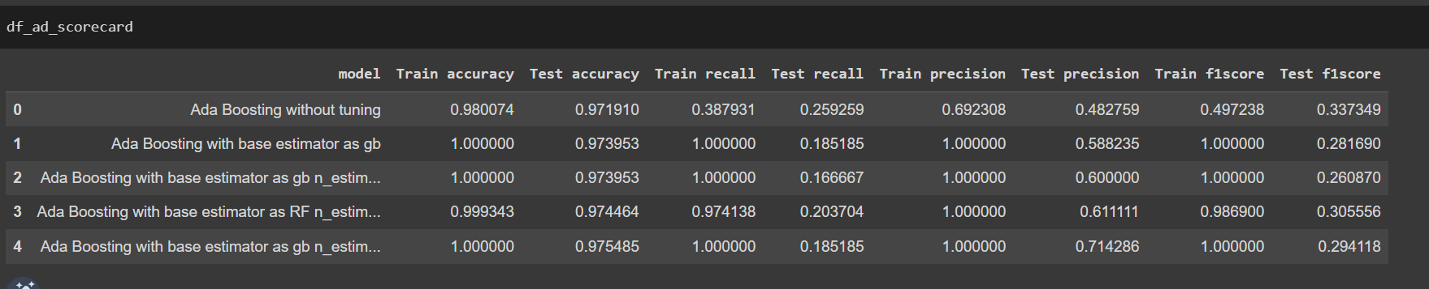

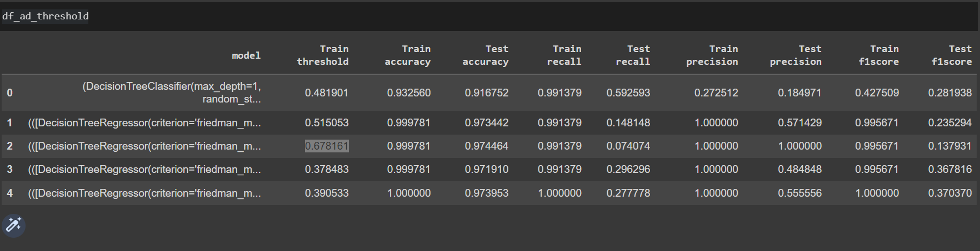

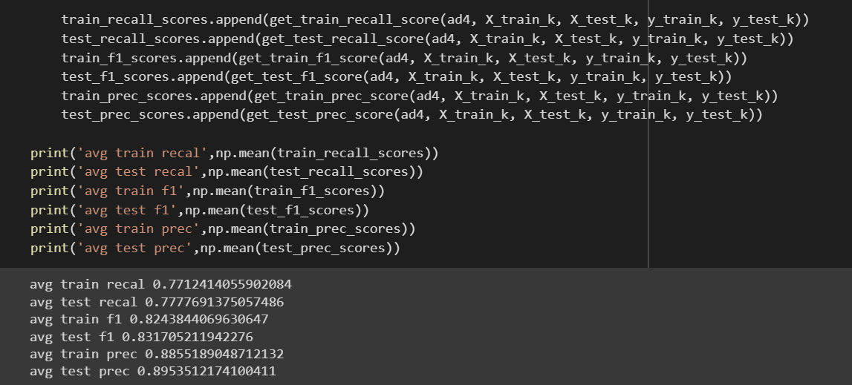

# Stacking Classifier

